Department of Chemistry Apparatus List Date 28/06/2021
S.No. | Date | Instrument Name | Quantity | Bill No. | Grant Name | Instrument Picture
1 | 17/03/2011 | U.V.-Vis Spectrophotometer | 1 | 1898 | DST | 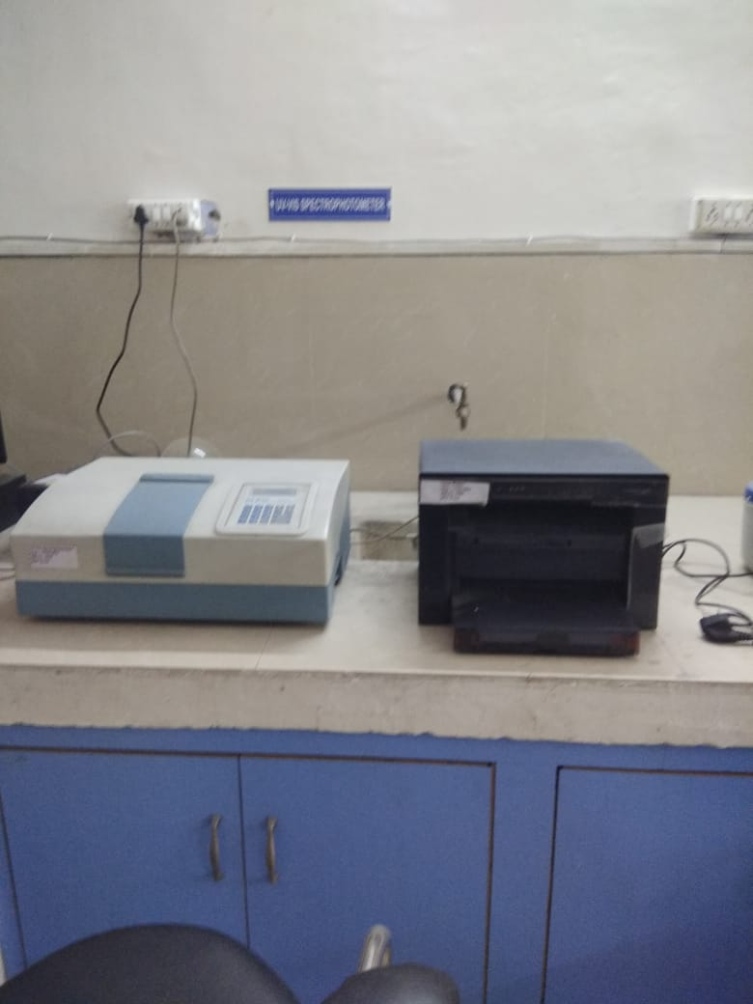
2 | 17/03/2011 | Thermo Fisher Gas Chromatograph | 1 | 1952 | DST | 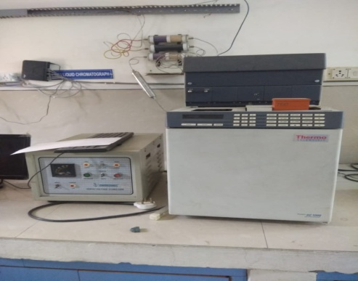
3 | 27/03/2012 | Gas Cylinder Hydroden,Nitrogen, Zero air | 3 | 2860 | DST
4 | 02-10-2012 | Microwave oven | 1 | 19682 | UGC | 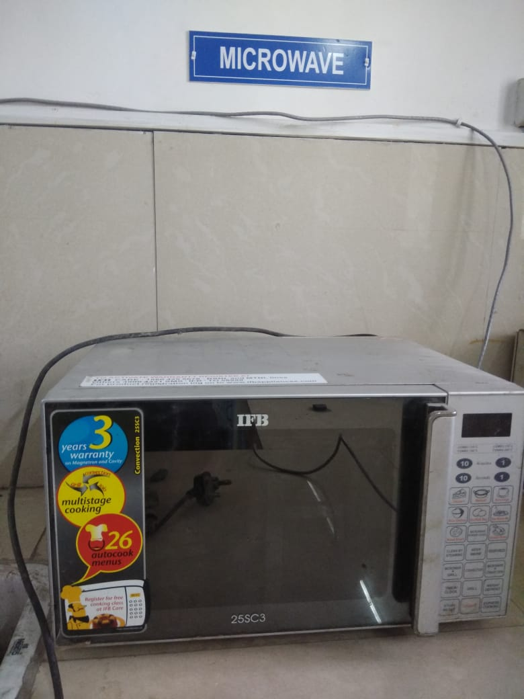
5 | 21/03/2012 | Multifriquency.Ultrasonic .Interferrometer | 1 | 215/2011-12 | UGC | 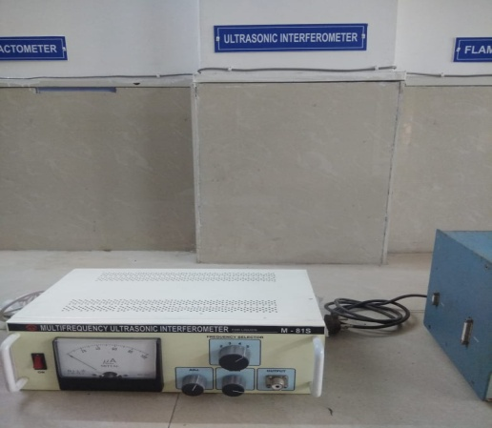
6 | 10-01-2012 | Isolation Transformer | 1 |  | UGC | 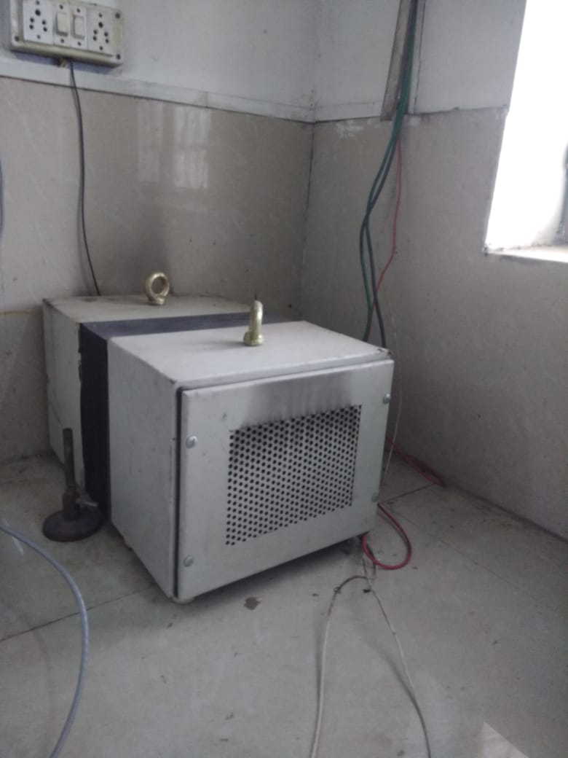
7 | 03-12-2013 | Hot Plate | 2 | 3317 | UGC Additional Grant | 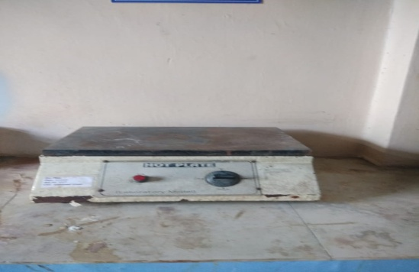
8 | 03-12-2013 | B.O.D. Incubator | 1 | 3317 | UGC Additional Grant | 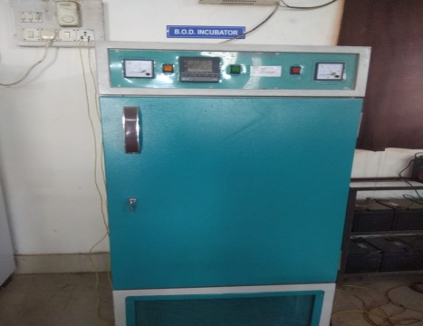
9 | 03-12-2013 | Centrifuse Machine | 1 | 3317 | UGC Additional Grant | 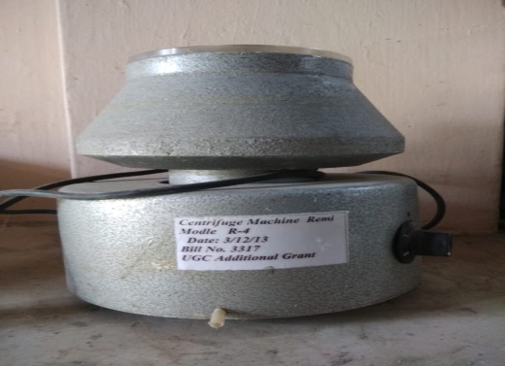
10 | 03-12-2013 | Rotatory Vaccume Film Evaporator | 1 | 3318 | UGC Additional Grant
11 | 03-12-2013 | Digital Rotatory Vaccume Film Evaporator | 1 | 3317 | UGC Additional Grant | 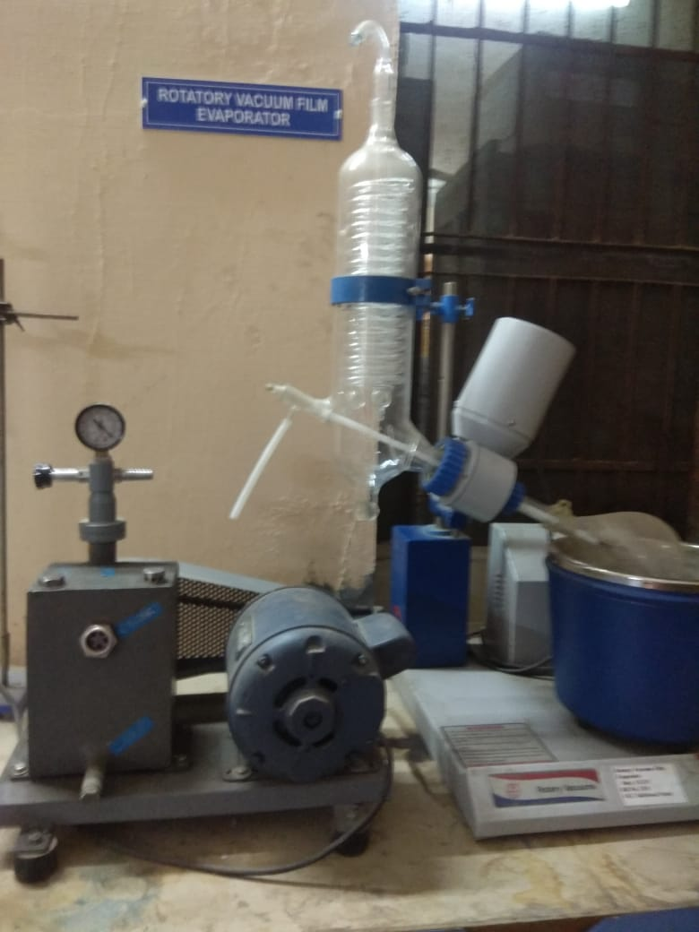
12 | 03-12-2013 | Soxlet apparatus | 2 | 3317 | UGC Additional Grant
13 | 03-12-2013 | Soxlet Apparatus | 6 | 3318 | UGC Additional Grant
14 | 03-12-2013 | Clavenzer Apparatus | 1 | 3317 | UGC Additional Grant
15 | 03-12-2013 | Water Bath | 2 | 3318 | UGC Additional Grant
16 | 03-12-2013 | Conducty Meter | 2 | 3318 | UGC Additional Grant
17 | 03-12-2013 | T.L.C. Kit | 2 | 3318 | UGC Additional Grant
18 | 03-12-2013 | Flame Photometer | 1 | 3318 | UGC Additional Grant | 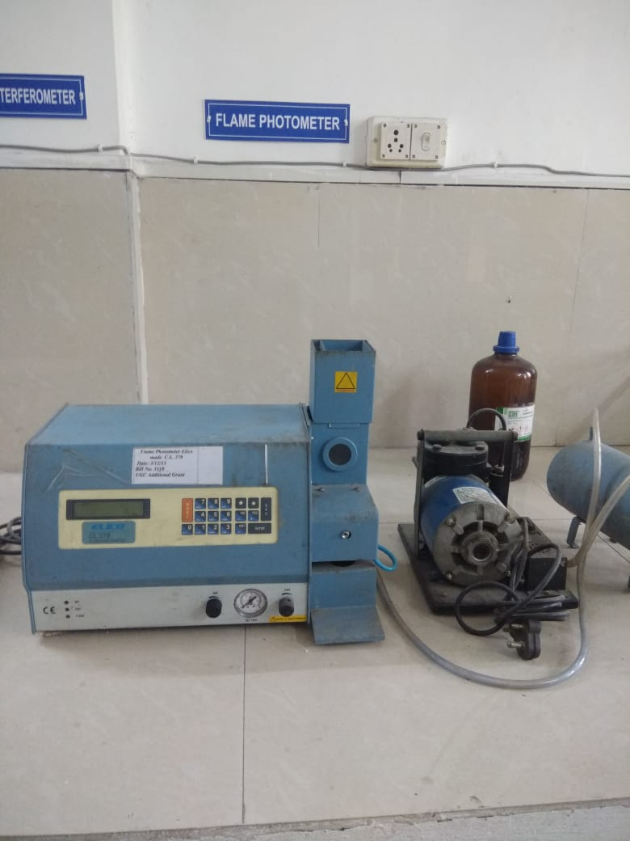
19 | 03-12-2013 | Auto Burette | 2 | 3318 | UGC Additional Grant
20 | 03-12-2013 | Abbs refrectometer | 1 | 3318 | UGC Additional Grant | 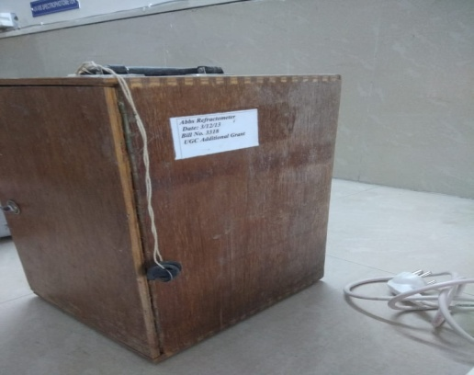
21 | 03-12-2013 | Membrane Filtration Assembly | 1 | 3318 | UGC Additional Grant
22 | 03-12-2013 | Nephelometer | 1 | 3318 | UGC Additional Grant | 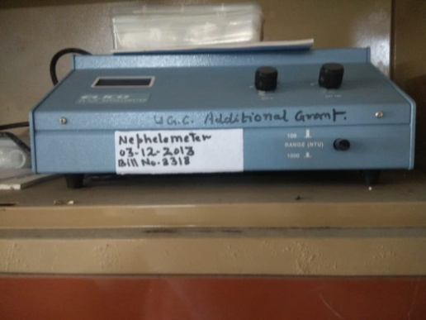
23 | 03-12-2013 | Heating Mental | 4 | 3318 | UGC Additional Grant | 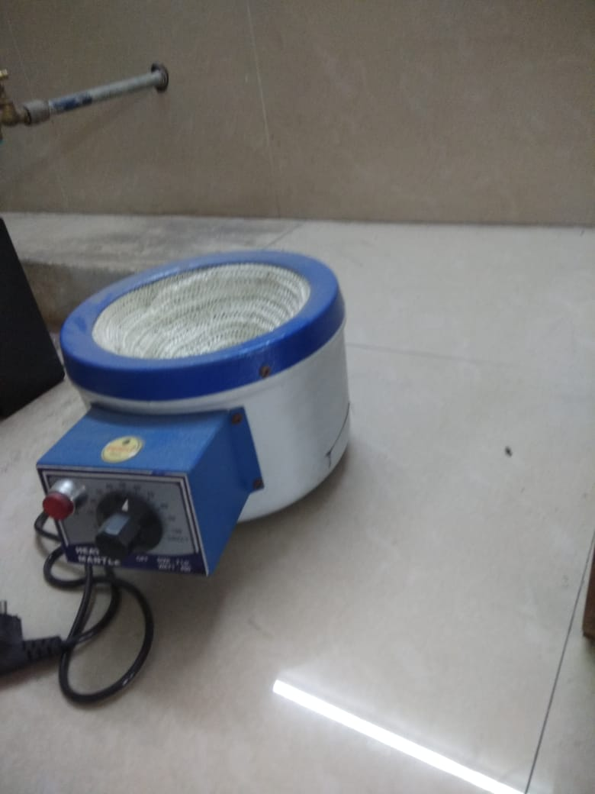
24 | 03-12-2013 | Leminar Air flow | 1 | 3318 | UGC Additional Grant | 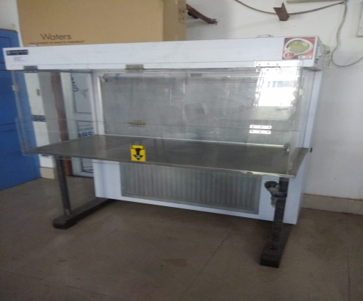
25 | 03-12-2013 | Water Bath Electric | 2 | 3318 | UGC Additional Grant
26 | 22/06/2015 | FT-IR | 1 | 3959 | UGC CPE | 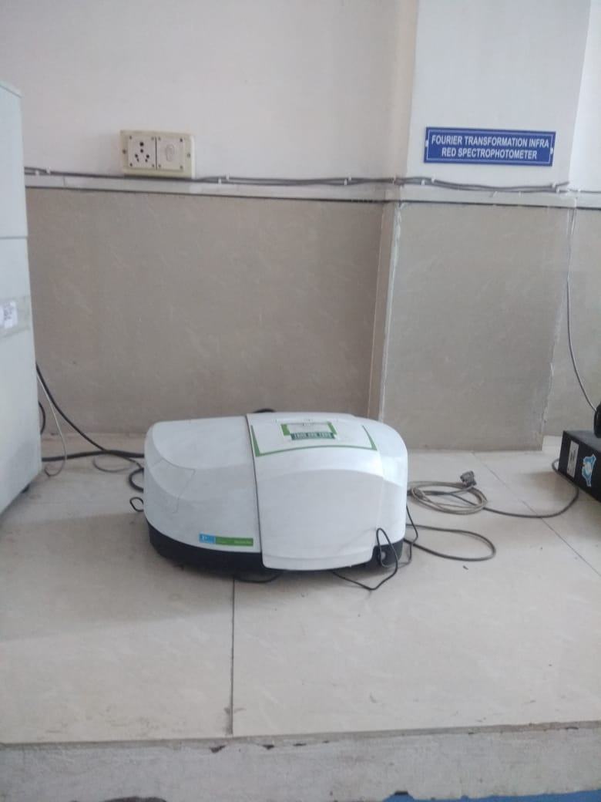
27 | 22/6/2015 | Pellete making Press | 1 | 3959 | UGC CPE
28 | 22/6/2015 | P.C with lazer Printer | 1 | 3959 | UGC CPE
29 | 22/6/2015 | On Line UPS | 1 | 3959 | UGC CPE | 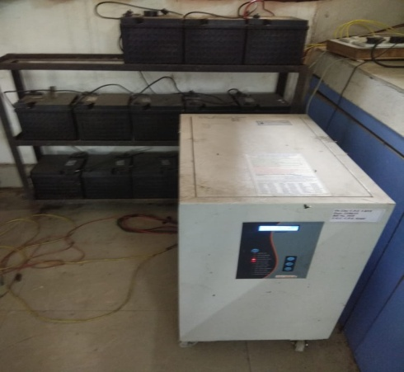
30 | 06-03-2018 | Soxlet apparatus | 1 | PCT/DDN/17-18/07 | UGC CPE I Phase II part
31 | 06-03-2018 | Clavenger Apparatus | 2 | PCT/DDN/17-18/07 | UGC CPE I Phase II part
32 | 29/6/2020 | HPLC | 1 | HT/20-21/050 | UGC CPE II Cycle | 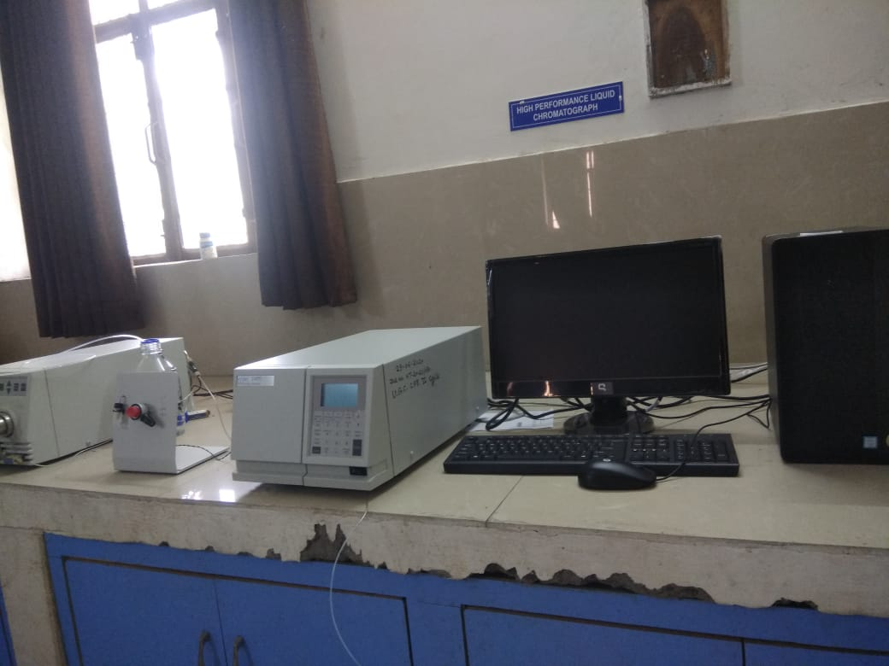
33 | 09-10-2020 | Conductivity Meter | 4 | HT/20-21/091 | RUSA
34 | 09-10-2020 | Potentiometer | 3 | HT/20-21/091 | RUSA
35 | 09-10-2020 | Digital Balance 1mg | 1 | HT/20-21/091 | RUSA | 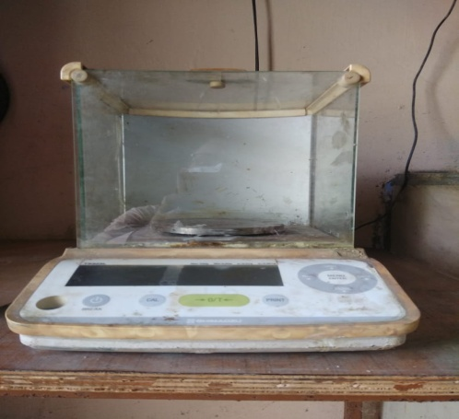
36 | 09-10-2020 | Digital Balance 1mg | 1 | HT/20-21/091 | RUSA
37 | 09-10-2020 | Calorimeter | 10 | HT/20-21/091 | RUSA
38 | 09-10-2020 | Distillation Assambly | 10 | HT/20-21/091 | RUSA | 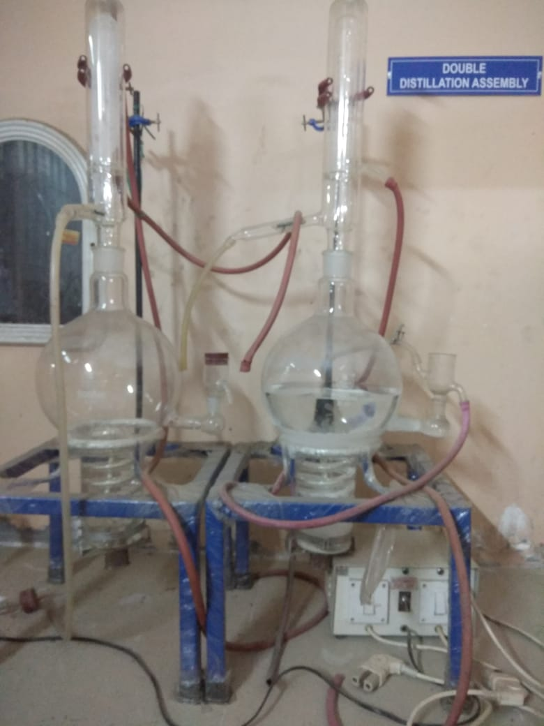
39 | 09-10-2020 | pH -Meter | 6 | HT/20-21/091 | RUSA
40 | 09-10-2020 | pH-Meter Microprocessor Based Elico | 2 | HT/20-21/091 | RUSA
41 |  | LCD Projector | 1
42 |  | Computer | 3 |  |  | 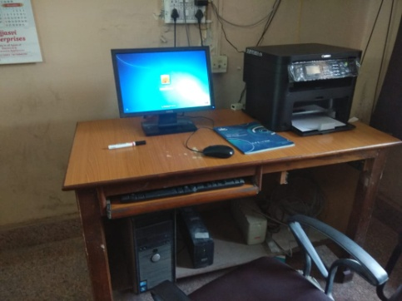
43 | 25/9/2020 | Water Nano Purifier | 1 |  |  | 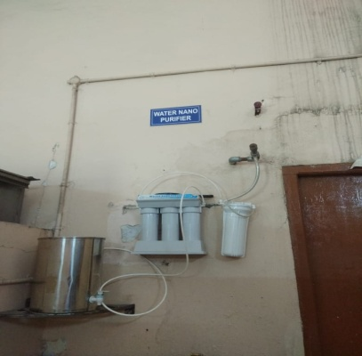
44 |  | Aquaguard Classic | 1 |  |  | 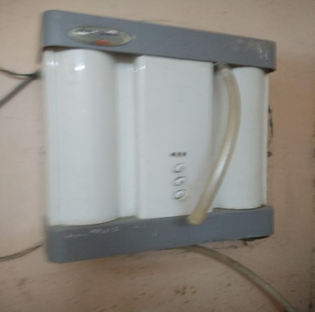
45 |  | Milk Testing Machine | 1
46 |  | Fridge ( Samsung ) | 1 |  |  | 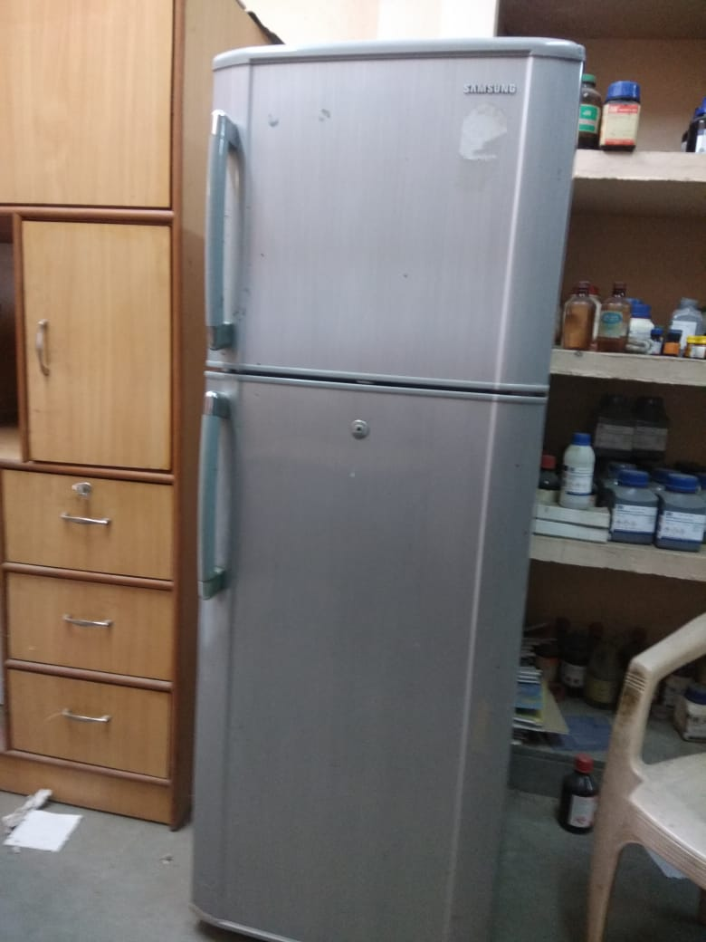
47 |  | Fire Extingusir | 8 |  |  | 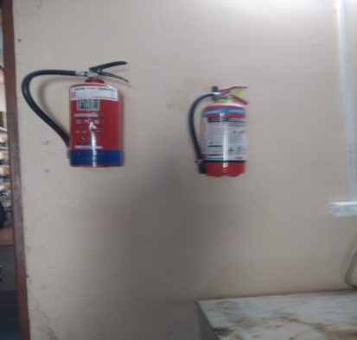
48 |  | TLC Chamber | 1
49 |  | Vaccume Oven | 1
50 |  | Inverter | 1
51 |  | Fire Extingusheir | 8
52 |  | Hot Oven | 2 |  |  | 